

Midnight Cry

210 Avenue B

Snohomish, WA 98290

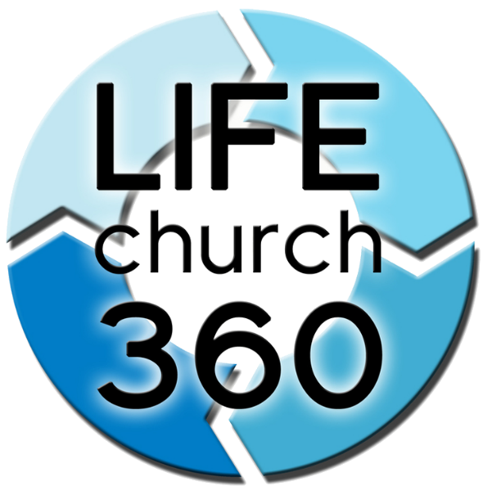

LIFEchurch360

3131 Smokey Point Drive

****Arlington, WA 98223